A Mini Project Report

on

**Courier Management System**

By

**A NITEESH REDDY**

**1602-18-733-029**

**D NIKHIL SAI**

**1602-18-733-028**



**Department of Computer Science & Engineering**

**Vasavi College of Engineering (Autonomous)**

**(Affiliated to Osmania University)**

**Ibrahimbagh, Hyderabad-31**

**2020**

**ACKNOWLEDGEMENT**

We take this opportunity with pride and enormous gratitude, to express the deeply embedded feeling and gratefulness to our respectable guide **Mrs. Shyamala,** Department of Computer Science and Engineering. Whose guidance was unforgettable and innovative ideas as well as his constructive suggestions has made the presentation of my thesis a grand success.

We are thankful to **Dr. T. Adilakshmi,** Head of Department (CSE), **Vasavi College of Engineering** for their help during our course work.

Finally, at last but not least express our heart full thanks to the management of our college, **Vasavi College of Engineering** for providing the necessary arrangements and support to complete our project work successively.

# ABSTRACT

The main aim of Courier Management Mini DBMS project is to deliver the parcel. We aim to demonstrate the use of create, read, update and delete MySQL operations through this project. The project starts by adding details of courier branch and staffs working in their respective branches. The staff then adds sender and receiver details of that parcel i,e. Booking details. Then, the parcel is scheduled for delivery. Now, when the parcel is received by the receiver branch, they deliver the parcel and delivery status is shown.

**TABLES OF CONTENT**

1. Introduction
2. Architecture and technology used
3. Design of database
4. Code and implementation
5. Result or Output
6. Conclusion and future work
7. References

**INTRODUCTION**

**THROUGH THE PROJECT:**

This project helps to store data in a efficient way and it can be achieved through various sql commands and we can also store this for any future use and also we can save our data in a many different areas so we cannot lost all the data at once. The user details cannot be lost so it is safer to use it . Users details can be made and also make to visible only to the users and also employee details can be make to visible to only employee, we can make this and can happen. And also by this we can track every ones data in a simple way and also we can make thus available to them and useful .

**LIST OF TABLES:**

**Data base name:** Courier Management System.

**No of tables:** 5

1. **ACCOUNT**

1. **STAFF**

1. **BOOKING**

1. **DELIVERY**

1. **SCHEDULE**

**ARCHITECTURE AND TECHNOLOGY USED**

**SOFTWARE USED:**

Java Eclipse EE, Php my admin(XAMPP).

**Java SWING:**

Swing is a GUI widget toolkit for Java. It is part of Oracle's Java Foundation Classes (JFC) – an API for providing a graphical user interface (GUI) for Java programs.

Swing was developed to provide a more sophisticated set of GUI components than the earlier AWT. Swing provides a look and feel that emulates the look and feel of several platforms, and also supports a pluggable look and feel that allows applications to have a look and feel unrelated to the underlying platform. It has more powerful and flexible components than AWT. In addition to familiar components such as buttons, check boxes and labels, Swing provides several advanced components such as tabbed panel, scroll panes, trees, tables, and lists.

**SQL:**

Structure Query Language(SQL) is a database query language used for storing and managing data in Relational DBMS. SQL was the first commercial language introduced for E.F

Codd's **Relational** model of database. Today almost all RDBMS (MySql, Oracle, Infomix, Sybase, MS Access) use **SQL** as the standard database query language. SQL is used to perform all types of data operations in RDBMS.

**Java-SQL Connectivity using JDBC:**

**Java Database Connectivity** (**JDBC**) is an application programming interface (API) for the programming language Java, which defines how a client may access a database. It is a Java- based data access technology used for Java database connectivity. It is part of the Java Standard Edition platform, from Oracle Corporation. It provides methods to query and update data in a database and is oriented towards relational databases.

**CODE AND IMPLEMENTATION**

**Staff.java**

package Management;

import java.awt.Color;

import java.awt.Font;

import java.awt.event.ActionEvent;

import java.awt.event.ActionListener;

import java.awt.*;

import javax.swing.JButton;

import javax.swing.JFrame;

import javax.swing.JLabel;

import javax.swing.JTextField;

public class search extends JFrame implements ActionListener {

JFrame f;

JTextField tf;

JLabel l1;

JButton b1,b2;

search()

{

f=new JFrame("View");

f.setBackground(Color.GREEN);

f.setLayout(null);

l1=new JLabel("Courier Number");

l1.setBounds(40,60,250,30);

l1.setForeground(Color.BLACK);

Font F1 = new Font("serif",Font.BOLD,30);

l1.setFont(F1);

f.add(l1);

tf=new JTextField();

tf.setBounds(300,60,220,30);

f.add(tf);

b1=new JButton("Search");

b1.setBounds(240,150,100,30);

b1.addActionListener(this);

f.add(b1);

b2=new JButton("Cancel");

b2.setBounds(360,150,100,30);

b2.addActionListener(this);

f.add(b2);

f.setVisible(true);

f.setSize(900,700);

f.getContentPane().setBackground(Color.cyan);

f.setLocation(400,150);

}

public void actionPerformed(ActionEvent ae)

{

String a=tf.getText();

int b=Integer.parseInt(a);

if(ae.getSource() == b2)

{

f.setVisible(false);

options o=new options();

}

if(ae.getSource() == b1)

{

f.setVisible(false);

display c=new display(b);

}

}

public static void main(String[] args) {

// TODO Auto-generated method stub

search p=new search();

}

}

**Booking.java**

package Management;

import java.awt.*;

import java.awt.event.*;

import javax.swing.*;

import java.sql.*;

public class booking extends JFrame implements ActionListener {

JFrame f;

JLabel l,l1,lt1,l2,lt2,l3,lt3,l4,l5,l6,l7,l8;

JTextField t1,t2,t3,t4,t5,t6;

JButton b1,b2;

String name,address,contact;

booking(int eid)

{

try {

conn con=new conn();

String str="select * from staff where empid= " + eid;

ResultSet rs=con.s.executeQuery(str);

while(rs.next())

{

name=rs.getString("name");

address=rs.getString("branchaddress");

contact=rs.getString("contact");

}

}catch(Exception e)

{

e.printStackTrace();

}

f=new JFrame("Booking");

f.setBackground(Color.white);

f.setLayout(null);

l=new JLabel("Booking Details");

l.setBounds(200,10,250,30);

l.setFont(new Font("serif",Font.BOLD,25));

f.add(l);

l1=new JLabel("Name");

l1.setBounds(50,70,200,30);

l1.setFont(new Font("serif",Font.BOLD,25));

f.add(l1);

lt1=new JLabel(name);

lt1.setBounds(270, 70, 120, 30);

lt1.setFont(new Font("serif",Font.BOLD,25));

f.add(lt1);

l2=new JLabel("Branch Address");

l2.setBounds(50,120,200,30);

l2.setFont(new Font("serif",Font.BOLD,25));

f.add(l2);

lt2=new JLabel(address);

lt2.setBounds(270, 120, 150, 30);

lt2.setFont(new Font("serif",Font.BOLD,25));

f.add(lt2);

l3=new JLabel("Contact No");

l3.setBounds(50,170,200,30);

l3.setFont(new Font("serif",Font.BOLD,25));

f.add(l3);

lt3=new JLabel(contact);

lt3.setBounds(270, 170, 180, 30);

lt3.setFont(new Font("serif",Font.BOLD,25));

f.add(lt3);

l4=new JLabel("Courier Weight");

l4.setBounds(50,220,200,30);

l4.setFont(new Font("serif",Font.BOLD,25));

f.add(l4);

t1=new JTextField();

t1.setBounds(270, 220, 150, 30);

f.add(t1);

l5=new JLabel("Courier Type");

l5.setBounds(50,270,200,30);

l5.setFont(new Font("serif",Font.BOLD,25));

f.add(l5);

t2=new JTextField();

t2.setBounds(270, 270, 150, 30);

f.add(t2);

l6=new JLabel("Courier Number");

l6.setBounds(50,320,200,30);

l6.setFont(new Font("serif",Font.BOLD,25));

f.add(l6);

t3=new JTextField();

t3.setBounds(270, 320, 150, 30);

f.add(t3);

b1=new JButton("Submit");

b1.setBackground(Color.BLACK);

b1.setForeground(Color.WHITE);

b1.setBounds(100,400,100,50);

b1.addActionListener(this);

f.add(b1);

b2=new JButton("cancel");

b2.setBackground(Color.BLACK);

b2.setForeground(Color.WHITE);

b2.setBounds(250,400,100,50);

b2.addActionListener(this);

f.add(b2);

f.setVisible(true);

f.setSize(595,642);

f.getContentPane().setBackground(Color.YELLOW);

f.setLocation(450,200);

}

public void actionPerformed(ActionEvent ae)

{

String a=t1.getText();

String b=t2.getText();

String c=t3.getText();

int d=Integer.parseInt(c);

if(ae.getSource() == b1)

{

try {

conn c1=new conn();

String q="insert into booking(name, branchaddress, contact, courierweight, couriertype, couriernumber) values('" + name + "', '" + address + "','" + contact + "','" + a +"','" + b + "','" + d + "')";

c1.s.executeUpdate(q);

JOptionPane.showMessageDialog(null,"Details Successfully Inserted");

this.setVisible(false);

new options();

}catch(Exception e1)

{

e1.printStackTrace();

}

}

if(ae.getSource() == b2)

{

this.setVisible(false);

new options();

}

}

public static void main(String[] args) {

// TODO Auto-generated method stub

booking b=new booking(10);

}

}

**Conn.java**

**package** Management;

**import** java.sql.*;

**public** **class** conn {

// **TODO** Auto-generated method stub

Connection c;

Statement s;

**public** conn()

{

**try** {

Class.*forName*("com.mysql.jdbc.Driver");

c= DriverManager.*getConnection*("jdbc:mysql://localhost/courier management system?" +

"user=root&password=");

s=c.createStatement();

}**catch**(Exception e)

{

System.***out***.println(e);

}

}

}

**Delivery.java**

package Management;

import java.awt.*;

import java.awt.event.*;

import javax.swing.*;

import java.sql.*;

public class delivery extends JFrame implements ActionListener{

JFrame f;

JLabel l,l1,l2,l3,l4,l5;

JTextField tf1,tf2,tf3,tf4,tf5;

JButton b1,b2;

delivery()

{

f=new JFrame("Delivery");

f.setBackground(Color.white);

f.setLayout(null);

l=new JLabel("Delivery Details");

l.setBounds(200,10,250,30);

l.setFont(new Font("serif",Font.BOLD,25));

f.add(l);

l1=new JLabel("Courier Number");

l1.setBounds(50, 100, 200, 40);

l1.setFont(new Font("serif",Font.BOLD,25));

f.add(l1);

tf1=new JTextField();

tf1.setBounds(270, 100, 150, 40);

f.add(tf1);

l2=new JLabel("Branch Name");

l2.setBounds(50, 160, 200, 40);

l2.setFont(new Font("serif",Font.BOLD,25));

f.add(l2);

tf2=new JTextField();

tf2.setBounds(270, 160, 150, 40);

f.add(tf2);

l3=new JLabel("Staff Name");

l3.setBounds(50, 220, 200, 40);

l3.setFont(new Font("serif",Font.BOLD,25));

f.add(l3);

tf3=new JTextField();

tf3.setBounds(270, 220, 150, 40);

f.add(tf3);

l4=new JLabel("Delivered To");

l4.setBounds(50, 280, 200, 40);

l4.setFont(new Font("serif",Font.BOLD,25));

f.add(l4);

tf4=new JTextField();

tf4.setBounds(270, 280, 150, 40);

f.add(tf4);

l5=new JLabel("Delivered on");

l5.setBounds(50, 340, 200, 40);

l5.setFont(new Font("serif",Font.BOLD,25));

f.add(l5);

tf5=new JTextField();

tf5.setBounds(270, 340, 150, 40);

f.add(tf5);

b1=new JButton("Submit");

b1.setBackground(Color.BLACK);

b1.setForeground(Color.WHITE);

b1.setBounds(100,420,100,50);

b1.addActionListener(this);

f.add(b1);

b2=new JButton("cancel");

b2.setBackground(Color.BLACK);

b2.setForeground(Color.WHITE);

b2.setBounds(250,420,100,50);

b2.addActionListener(this);

f.add(b2);

f.setVisible(true);

f.setSize(900,700);

f.getContentPane().setBackground(Color.YELLOW);

f.setLocation(400,150);

}

public void actionPerformed(ActionEvent ae)

{

String a=tf1.getText();

String b=tf2.getText();

String c=tf3.getText();

String d=tf4.getText();

String e=tf5.getText();

int f=Integer.parseInt(a);

if(ae.getSource() == b1)

{

try {

conn cc=new conn();

String q="insert into delivery (couriernumber, branchname, staffname, deliveredto, deliveredon) values('" + f + "' , '" + b + "' , '" + c + "','" + d + "','" + e + "')";

cc.s.executeUpdate(q);

JOptionPane.showMessageDialog(null,"Details Successfully Inserted");

this.setVisible(false);

new options();

}catch(Exception e1)

{

e1.printStackTrace();

}

}

if(ae.getSource() == b2)

{

this.setVisible(false);

new options();

}

}

public static void main(String[] args) {

// TODO Auto-generated method stub

delivery d=new delivery();

}

}

**Display.java**

package Management;

import java.awt.*;

import java.sql.ResultSet;

import javax.swing.*;

public class display {

JFrame f;

JLabel l,l1,lt1,l2,lt2,l3,lt3,l4,lt4,l5,lt5;

String name,address,contact,cwgt,ctype,cn;

display(int cid)

{

try {

conn con=new conn();

String str="select * from booking where couriernumber= " + cid;

ResultSet rs=con.s.executeQuery(str);

while(rs.next())

{

name=rs.getString("name");

address=rs.getString("branchaddress");

contact=rs.getString("contact");

cwgt=rs.getString("courierweight");

ctype=rs.getString("couriertype");

}

}catch(Exception e)

{

e.printStackTrace();

}

f=new JFrame("Booking");

f.setBackground(Color.white);

f.setLayout(null);

l=new JLabel("Booking Details");

l.setBounds(200,10,250,30);

l.setFont(new Font("serif",Font.BOLD,25));

f.add(l);

l1=new JLabel("Name");

l1.setBounds(50,70,200,30);

l1.setFont(new Font("serif",Font.BOLD,25));

f.add(l1);

lt1=new JLabel(name);

lt1.setBounds(270, 70, 120, 30);

lt1.setFont(new Font("serif",Font.BOLD,25));

f.add(lt1);

l2=new JLabel("Branch Address");

l2.setBounds(50,120,200,30);

l2.setFont(new Font("serif",Font.BOLD,25));

f.add(l2);

lt2=new JLabel(address);

lt2.setBounds(270, 120, 150, 30);

lt2.setFont(new Font("serif",Font.BOLD,25));

f.add(lt2);

l3=new JLabel("Contact No");

l3.setBounds(50,170,200,30);

l3.setFont(new Font("serif",Font.BOLD,25));

f.add(l3);

lt3=new JLabel(contact);

lt3.setBounds(270, 170, 180, 30);

lt3.setFont(new Font("serif",Font.BOLD,25));

f.add(lt3);

l4=new JLabel("Courier Weight");

l4.setBounds(50,220,200,30);

l4.setFont(new Font("serif",Font.BOLD,25));

f.add(l4);

lt4=new JLabel(cwgt);

lt4.setBounds(270, 220, 150, 30);

lt4.setFont(new Font("serif",Font.BOLD,25));

f.add(lt4);

l5=new JLabel("Courier Type");

l5.setBounds(50,270,200,30);

l5.setFont(new Font("serif",Font.BOLD,25));

f.add(l5);

lt5=new JLabel(ctype);

lt5.setBounds(270, 270, 150, 30);

lt5.setFont(new Font("serif",Font.BOLD,25));

f.add(lt5);

f.setVisible(true);

f.setSize(595,642);

f.getContentPane().setBackground(Color.YELLOW);

f.setLocation(450,200);

}

public static void main(String[] args) {

// TODO Auto-generated method stub

display d=new display(10);

}

}

**Intro.java**

package Management;

import java.awt.*;

import java.awt.event.*;

import javax.swing.*;

public class intro extends JFrame implements ActionListener{

JFrame f;

JButton b;

JLabel l;

intro()

{

f=new JFrame();

f.setLayout(null);

l=new JLabel("Courier Management System");

l.setFont(new Font("serif",Font.ITALIC,25));

l.setBounds(270,50,1500,100);

l.setForeground(Color.BLACK);

f.add(l);

b=new JButton("Click Here");

b.setForeground(Color.BLACK);

b.setBounds(380,250,100,50);

b.setBackground(Color.BLUE);

b.addActionListener(this);

f.add(b);

f.setVisible(true);

f.setSize(900,400);

f.getContentPane().setBackground(Color.ORANGE);

f.setLocation(200,100);

while(true)

{

l.setVisible(false);

try {

Thread.sleep(200);

}catch(Exception e){}

l.setVisible(true);

try {

Thread.sleep(500);

}catch(Exception e) {}

}

}

public void actionPerformed(ActionEvent ae)

{

if(ae.getSource() == b)

{

f.setVisible(false);

new login().setVisible(true);

}

}

public static void main(String[] args) {

// TODO Auto-generated method stub

new intro();

}

}

**Login.java**

package Management;

import java.awt.*;

import java.awt.event.*;

import javax.swing.*;

import java.awt.*;

import java.sql.*;

public class login extends JFrame implements ActionListener {

private JPanel panel;//It is same as div in html

private JTextField textfield;

private JPasswordField passwordfield;

private JButton b1,b2;

public login()

{

setLayout(null);

setBackground(new Color(169,169,169));

setBounds(600,300,600,400);

panel=new JPanel();

panel.setBackground(Color.PINK);

setContentPane(panel);

panel.setLayout(null);

JLabel l=new JLabel("LOGIN");

l.setBounds(224,30,150,50);

l.setForeground(Color.BLACK);

panel.add(l);

JLabel l1=new JLabel("USERNAME : ");

l1.setBounds(124,89,95,24);

panel.add(l1);

JLabel l2=new JLabel("PASSWORD : ");

l2.setBounds(124,124,95,24);

panel.add(l2);

textfield = new JTextField();

textfield.setBounds(210,93,157,20);

panel.add(textfield);

passwordfield=new JPasswordField();

passwordfield.setBounds(210,128,157,20);

panel.add(passwordfield);

JLabel l3=new JLabel("");

l3.setBounds(377,79,46,34);

panel.add(l3);

b1=new JButton("Login");

b1.addActionListener(this);

b1.setForeground(Color.CYAN);

b1.setBackground(Color.BLUE);

b1.setBounds(149,181,113,39);

panel.add(b1);

b2=new JButton("Signup");

b2.addActionListener(this);

b2.setForeground(Color.CYAN);

b2.setBackground(Color.BLUE);

b2.setBounds(289,181,113,39);

panel.add(b2);

}

public void actionPerformed(ActionEvent ae)

{

if(ae.getSource() == b1)

{

boolean status =false;

try {

conn con=new conn();

String sql="select * from account where username=? and password=?";

PreparedStatement st=con.c.prepareStatement(sql);

st.setString(1, textfield.getText());

st.setString(2,passwordfield.getText() );

ResultSet rs=st.executeQuery();

if(rs.next())

{

this.setVisible(false);

new Add_staff().setVisible(true);

}else {

JOptionPane.showMessageDialog(null,"Invalid Login");

}

}catch(Exception e)

{

e.printStackTrace();

}

}

if(ae.getSource() == b2)

{

this.setVisible(false);

new Signup().setVisible(true);

}

}

public static void main(String[] args) {

// TODO Auto-generated method stub

new login().setVisible(true);

}

}

**Options.java**

package Management;

import java.awt.*;

import javax.swing.*;

import java.awt.event.*;

public class options implements ActionListener {

JFrame f;

JLabel l1,l2;

JButton b1,b2,b3,b4,b5;

options()

{

f=new JFrame("Buttons");

f.setBackground(Color.WHITE);

f.setLayout(null);

l1=new JLabel();

l1.setBounds(0,0,700,500);

l1.setLayout(null);

//ImageIcon i1=new ImageIcon(ClassLoader.getSystemResource(""))

//l1.setIcon(i1)

f.add(l1);

l2=new JLabel("OPTIONS");

l2.setBounds(200,20,230,50);

l2.setFont(new Font("serif",Font.BOLD,25));

l2.setForeground(Color.BLACK);

l1.add(l2);

b1=new JButton("Staff");

b1.setBounds(120,100,100,40);

b1.setFont(new Font("serif",Font.BOLD,25));

b1.addActionListener(this);

l1.add(b1);

b2=new JButton("Booking");

b2.setBounds(300,100,120,40);

b2.setFont(new Font("serif",Font.BOLD,25));

b2.addActionListener(this);

l1.add(b2);

b3=new JButton("Schedule");

b3.setBounds(120,160,150,40);

b3.setFont(new Font("serif",Font.BOLD,25));

b3.addActionListener(this);

l1.add(b3);

b4=new JButton("Delivery");

b4.setBounds(300,160,130,40);

b4.setFont(new Font("serif",Font.BOLD,25));

b4.addActionListener(this);

l1.add(b4);

b5=new JButton("Search");

b5.setBounds(210,220,130,40);

b5.setFont(new Font("serif",Font.BOLD,25));

b5.addActionListener(this);

l1.add(b5);

f.setVisible(true);

f.setSize(700,500);

f.getContentPane().setBackground(Color.CYAN);

f.setLocation(450, 200);

}

public void actionPerformed(ActionEvent ae)

{

if(ae.getSource()==b1){

f.setVisible(false);

new Add_staff();

}

if(ae.getSource()==b2){

f.setVisible(false);

new view();

}

if(ae.getSource()==b3){

f.setVisible(false);

new schedule();

}

if(ae.getSource()==b4){

f.setVisible(false);

new delivery();

}

if(ae.getSource() == b5)

{

f.setVisible(false);

new search();

}

}

public static void main(String[] args) {

// TODO Auto-generated method stub

options o=new options();

}

}

**Schedule.java**

package Management;

import java.awt.*;

import java.awt.event.*;

import javax.swing.*;

import java.sql.*;

public class schedule extends JFrame implements ActionListener{

JFrame f;

JLabel l,l1,l2,l3,l4;

JTextField tf1,tf2,tf3,tf4;

JButton b1,b2;

schedule()

{

f=new JFrame("Booking");

f.setBackground(Color.white);

f.setLayout(null);

l=new JLabel("Schedule Details");

l.setBounds(200,10,250,30);

l.setFont(new Font("serif",Font.BOLD,25));

f.add(l);

l1=new JLabel("Date");

l1.setBounds(50, 80, 200, 40);

l1.setFont(new Font("serif",Font.BOLD,25));

f.add(l1);

tf1=new JTextField();

tf1.setBounds(270, 80, 150, 40);

f.add(tf1);

l2=new JLabel("Courier Number");

l2.setBounds(50, 140, 200, 40);

l2.setFont(new Font("serif",Font.BOLD,25));

f.add(l2);

tf2=new JTextField();

tf2.setBounds(270, 140, 150, 40);

f.add(tf2);

l3=new JLabel("Branch Code");

l3.setBounds(50, 200, 200, 40);

l3.setFont(new Font("serif",Font.BOLD,25));

f.add(l3);

tf3=new JTextField();

tf3.setBounds(270, 200, 150, 40);

f.add(tf3);

l4=new JLabel("Staff Name");

l4.setBounds(50, 260, 200, 40);

l4.setFont(new Font("serif",Font.BOLD,25));

f.add(l4);

tf4=new JTextField();

tf4.setBounds(270, 260, 150, 40);

f.add(tf4);

b1=new JButton("Submit");

b1.setBackground(Color.BLACK);

b1.setForeground(Color.WHITE);

b1.setBounds(100,340,100,50);

b1.addActionListener(this);

f.add(b1);

b2=new JButton("cancel");

b2.setBackground(Color.BLACK);

b2.setForeground(Color.WHITE);

b2.setBounds(250,340,100,50);

b2.addActionListener(this);

f.add(b2);

f.setVisible(true);

f.setSize(900,700);

f.setLocation(400,150);

f.getContentPane().setBackground(Color.YELLOW);

}

public void actionPerformed(ActionEvent ae)

{

String a=tf1.getText();

String b=tf2.getText();

String c=tf3.getText();

String d=tf4.getText();

int e=Integer.parseInt(b);

int f=Integer.parseInt(c);

if(ae.getSource() == b1)

{

try {

conn cc=new conn();

String q="insert into schedule(date, couriernumber, branchcode, staffname) values('" + a + "' , '" + e + "' , '" + f + "','" + d + "')";

cc.s.executeUpdate(q);

JOptionPane.showMessageDialog(null,"Details Successfully Inserted");

this.setVisible(false);

new options();

}catch(Exception e1)

{

e1.printStackTrace();

}

}

if(ae.getSource() == b2)

{

this.setVisible(false);

new options();

}

}

public static void main(String[] args) {

// TODO Auto-generated method stub

schedule s=new schedule();

}

}

**Search.java**

package Management;

import java.awt.Color;

import java.awt.Font;

import java.awt.event.ActionEvent;

import java.awt.event.ActionListener;

import java.awt.*;

import javax.swing.JButton;

import javax.swing.JFrame;

import javax.swing.JLabel;

import javax.swing.JTextField;

public class search extends JFrame implements ActionListener {

JFrame f;

JTextField tf;

JLabel l1;

JButton b1,b2;

search()

{

f=new JFrame("View");

f.setBackground(Color.GREEN);

f.setLayout(null);

l1=new JLabel("Courier Number");

l1.setBounds(40,60,250,30);

l1.setForeground(Color.BLACK);

Font F1 = new Font("serif",Font.BOLD,30);

l1.setFont(F1);

f.add(l1);

tf=new JTextField();

tf.setBounds(300,60,220,30);

f.add(tf);

b1=new JButton("Search");

b1.setBounds(240,150,100,30);

b1.addActionListener(this);

f.add(b1);

b2=new JButton("Cancel");

b2.setBounds(360,150,100,30);

b2.addActionListener(this);

f.add(b2);

f.setVisible(true);

f.setSize(900,700);

f.getContentPane().setBackground(Color.cyan);

f.setLocation(400,150);

}

public void actionPerformed(ActionEvent ae)

{

String a=tf.getText();

int b=Integer.parseInt(a);

if(ae.getSource() == b2)

{

f.setVisible(false);

options o=new options();

}

if(ae.getSource() == b1)

{

f.setVisible(false);

display c=new display(b);

}

}

public static void main(String[] args) {

// TODO Auto-generated method stub

search p=new search();

}

}

**Signup.java**

package Management;

import java.awt.*;

import java.awt.event.*;

import javax.swing.*;

import javax.swing.border.EmptyBorder;

import java.sql.*;

public class Signup extends JFrame implements ActionListener{

private JPanel contentpane;

private JTextField textfield;

private JTextField textfield1;

private JTextField textfield2;

private JTextField textfield3;

private JButton b1,b2;

private JComboBox combobox;

public Signup()

{

setBounds(600,250,606,406);

contentpane=new JPanel();

contentpane.setBorder(new EmptyBorder(5,5,5,5));

setContentPane(contentpane);

contentpane.setBackground(Color.GREEN);

contentpane.setLayout(null);

JLabel lhead=new JLabel("SIGN UP");

lhead.setForeground(Color.BLACK);

lhead.setFont(new Font("Tahoma",Font.BOLD,14));

lhead.setBounds(250,20,150,70);

contentpane.add(lhead);

JLabel luser=new JLabel("USERNAME : ");

luser.setForeground(Color.DARK_GRAY);

luser.setFont(new Font("Tahoma",Font.BOLD,14));

luser.setBounds(99,86,150,26);

contentpane.add(luser);

JLabel lname=new JLabel("NAME : ");

lname.setForeground(Color.DARK_GRAY);

lname.setFont(new Font("Tahoma",Font.BOLD,14));

lname.setBounds(99,123,150,26);

contentpane.add(lname);

JLabel lpass=new JLabel("Password : ");

lpass.setForeground(Color.DARK_GRAY);

lpass.setFont(new Font("Tahoma",Font.BOLD,14));

lpass.setBounds(99,160,150,26);

contentpane.add(lpass);

JLabel lans=new JLabel("Answer : ");

lans.setForeground(Color.DARK_GRAY);

lans.setFont(new Font("Tahoma",Font.BOLD,14));

lans.setBounds(99,234,150,26);

contentpane.add(lans);

combobox=new JComboBox();

combobox.setModel(new DefaultComboBoxModel(new String[] {"Your Nickname?","Your Lucky name","Your favourite Cricketer"}));

combobox.setBounds(265,202,148,20);

contentpane.add(combobox);

JLabel lsec=new JLabel("Security Question:");

lsec.setForeground(Color.DARK_GRAY);

lsec.setFont(new Font("Tahoma",Font.BOLD,14));

lsec.setBounds(99,197,140,26);

contentpane.add(lsec);

textfield=new JTextField();

textfield.setBounds(265,91,148,20);

contentpane.add(textfield);

textfield.setColumns(10);

textfield1=new JTextField();

textfield1.setBounds(265,128,148,20);

contentpane.add(textfield1);

textfield1.setColumns(10);

textfield2=new JTextField();

textfield2.setBounds(265,165,148,20);

contentpane.add(textfield2);

textfield2.setColumns(10);

textfield3=new JTextField();

textfield3.setBounds(265,239,148,20);

contentpane.add(textfield3);

textfield3.setColumns(10);

b1=new JButton("Create");

b1.addActionListener(this);

b1.setFont(new Font("Tahoma",Font.BOLD,13));

b1.setBounds(140,289,100,30);

b1.setForeground(Color.BLACK);

b1.setBackground(Color.BLUE);

contentpane.add(b1);

b2=new JButton("Back");

b2.addActionListener(this);

b2.setFont(new Font("Tahoma",Font.BOLD,13));

b2.setBounds(300,289,100,30);

b2.setForeground(Color.BLACK);

b2.setBackground(Color.BLUE);

contentpane.add(b2);

JPanel panel=new JPanel();

panel.setForeground(Color.BLUE);

panel.setBounds(31,46,476,296);

panel.setBackground(Color.GREEN);

contentpane.add(panel);

}

public void actionPerformed(ActionEvent ae)

{

try {

conn con = new conn();

if(ae.getSource() == b1)

{

String sql="insert into account(username,name,password,sec_q,sec_ans) values(?,?,?,?,?)";

PreparedStatement st=con.c.prepareStatement(sql);

st.setString(1, textfield.getText());

st.setString(2, textfield1.getText());

st.setString(3, textfield2.getText());

st.setString(4, (String)combobox.getSelectedItem());

st.setString(5, textfield3.getText());

int i=st.executeUpdate();

System.out.println(i);

if(i > 0)

{

JOptionPane.showMessageDialog(null,"Successfully created");

}

textfield.setText("");

textfield1.setText("");

textfield2.setText("");

textfield3.setText("");

}

if(ae.getSource() == b2)

{

this.setVisible(false);

new login().setVisible(true);

}

}catch(Exception e)

{

e.printStackTrace();

}

}

public static void main(String[] args) {

// TODO Auto-generated method stub

new Signup().setVisible(true);

}

}

**View.java**

package Management;

import java.awt.*;

import javax.swing.*;

import java.awt.event.*;

public class view extends JFrame implements ActionListener{

JFrame f;

JTextField tf;

JLabel l1;

JButton b1,b2;

view()

{

f=new JFrame("View");

f.setBackground(Color.GREEN);

f.setLayout(null);

l1=new JLabel("Employee Id");

l1.setBounds(40,60,250,30);

l1.setForeground(Color.BLACK);

Font F1 = new Font("serif",Font.BOLD,30);

l1.setFont(F1);

f.add(l1);

tf=new JTextField();

tf.setBounds(240,60,220,30);

f.add(tf);

b1=new JButton("Search");

b1.setBounds(240,150,100,30);

b1.addActionListener(this);

f.add(b1);

b2=new JButton("Cancel");

b2.setBounds(360,150,100,30);

b2.addActionListener(this);

f.add(b2);

f.setVisible(true);

f.setSize(900,700);

f.getContentPane().setBackground(Color.cyan);

f.setLocation(400,150);

}

public void actionPerformed(ActionEvent ae)

{

String a=tf.getText();

int b=Integer.parseInt(a);

if(ae.getSource() == b2)

{

f.setVisible(false);

options o=new options();

}

if(ae.getSource() == b1)

{

f.setVisible(false);

booking c=new booking(b);

}

}

public static void main(String[] args) {

// TODO Auto-generated method stub

view p=new view();

}

}

**RESULT OR OUTPUT**

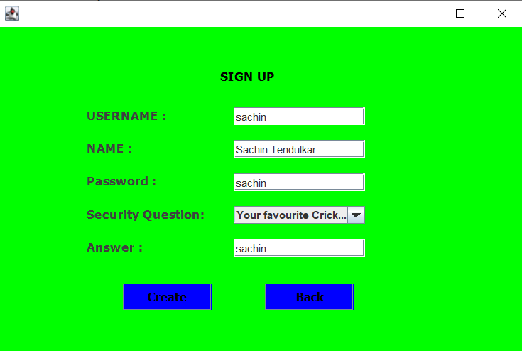

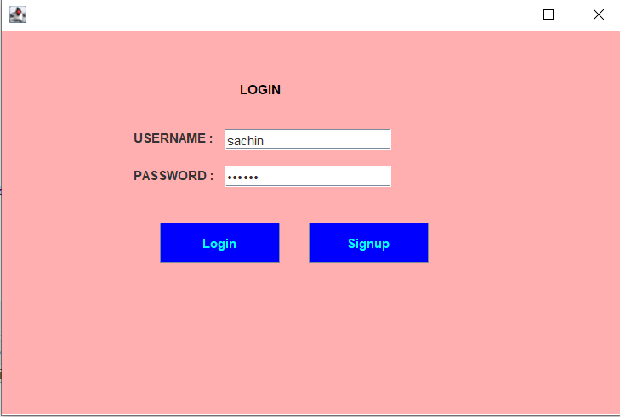

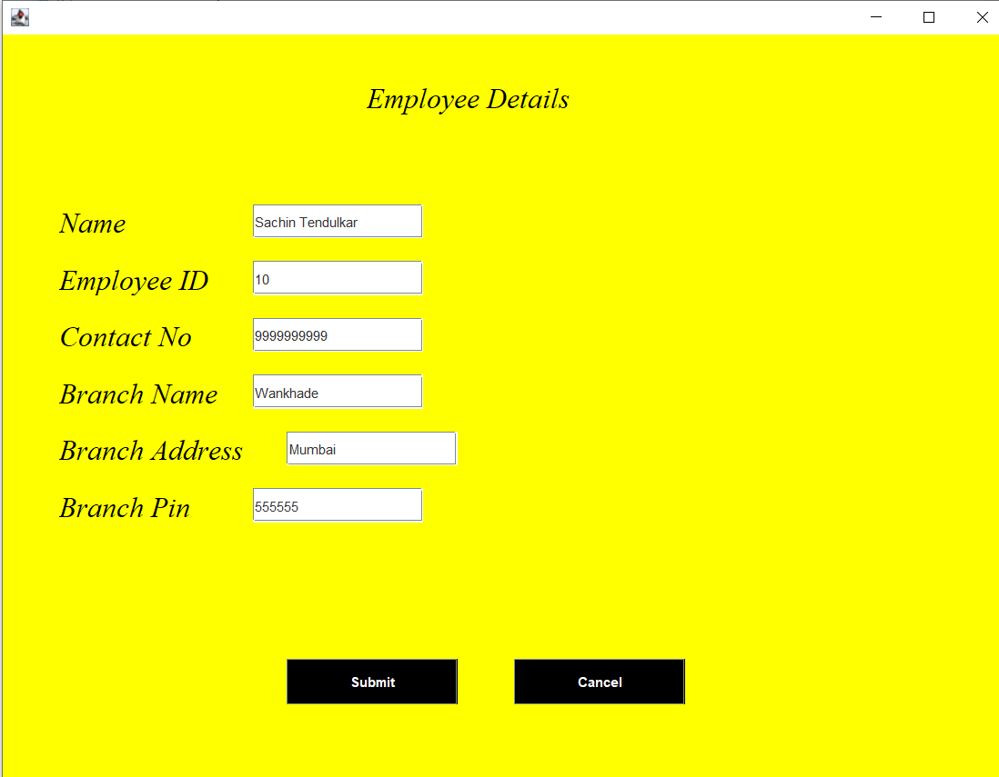

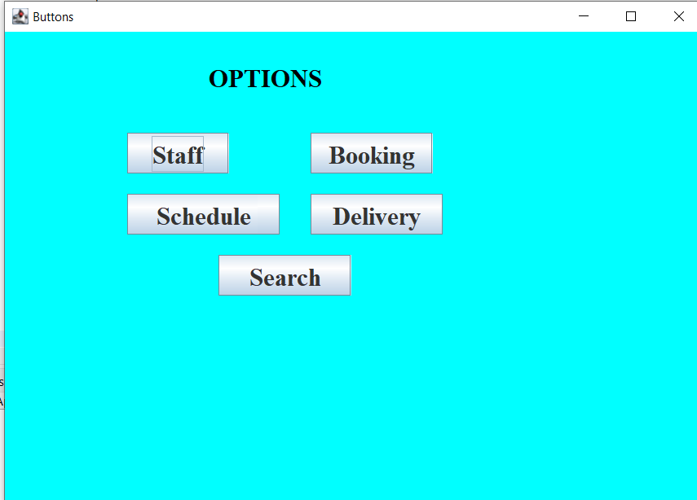

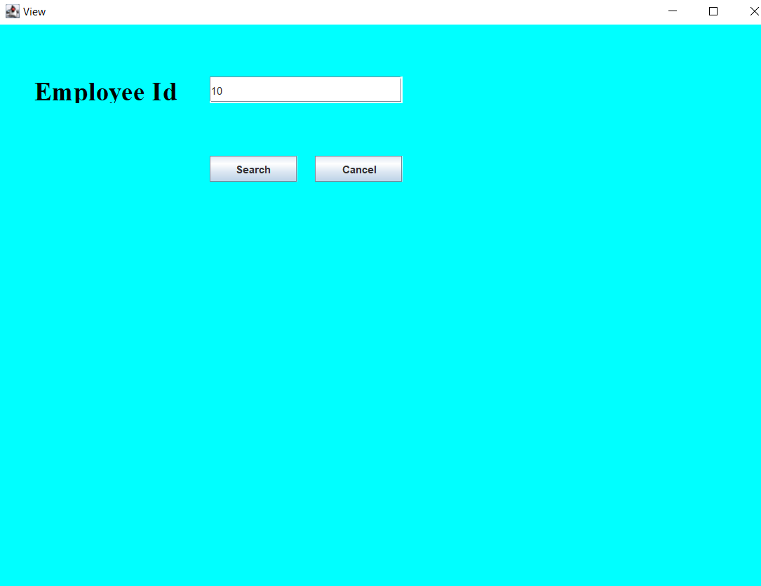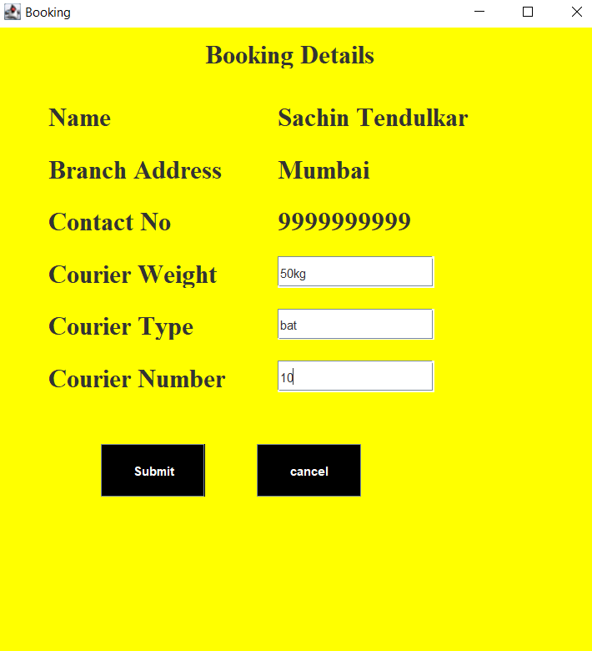

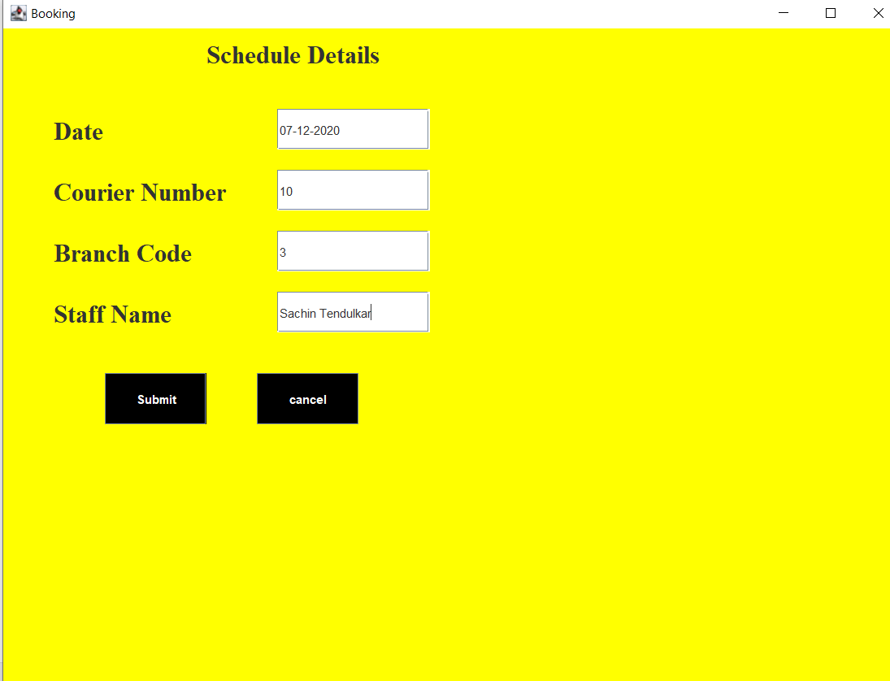

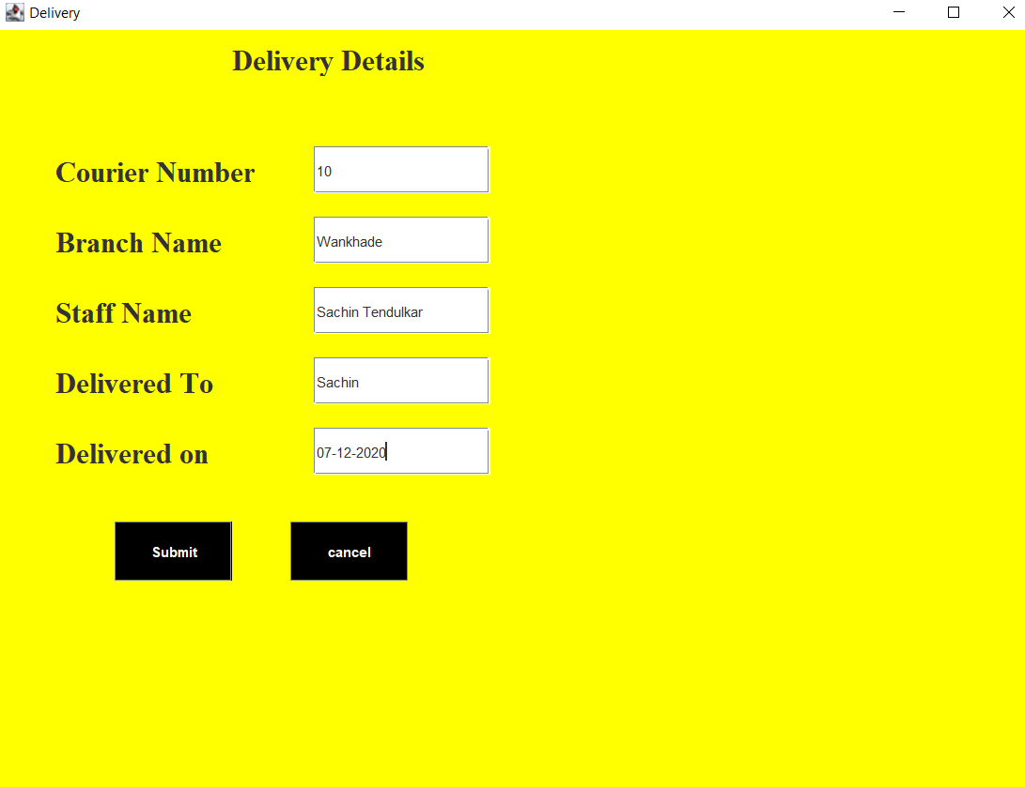

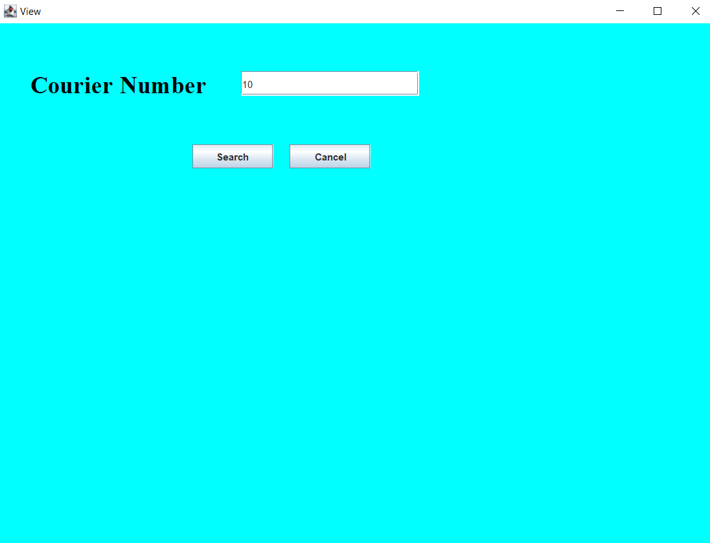

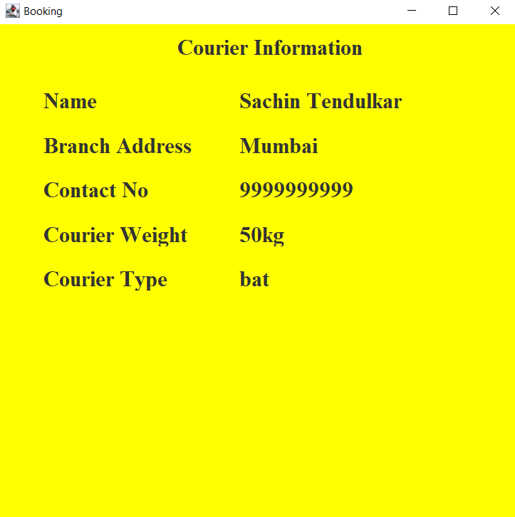

**CONCLUSION AND FUTURE WORK**

* By this project we can efficiently manage couriers and customers can view the data about courier by entering the courier id, staff can book ,schedule the couriers.
* In future we can develop web application so that all can access this and we can develop android application for this which makes even more easier for the customers. And also we can make a unified website for all courier services so that customers will have no confusion and also no need to remember different sites.

**REFERENCES**

* <https://docs.oracle.com/javaee/7/tutorial/>
* <https://www.javatpoint.com/dbms-tutorial>
* DATA SYSTEM CONCEPTS BY: Henry F korth.
* <https://www.w3schools.com/sql/>